**Forestry Education Centre**

**Meeting Sarah.**

When we went in to the building, it was like a real forest,

and then we went inside where we met Sarah,

the person who would be guiding us through the forest.

**Making a forest.**

Sarah helped us to be a perfect Eucalypt forest,

and I was a dead rotting log,but the fire came,

so then I was just part of the ash bed.

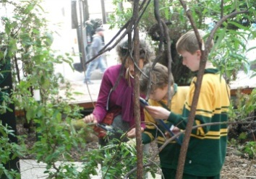

**Identifying Trees.**

When we were in the forest part of the building, we got to work straight away identifying trees from a euca-flip guide to trees. Joey and I didn’t get all of them right but we still had fun.

Bu Ingrid, Joey and I looking at trees.

**Insect traps.**

After we identified all the trees we got to try

and make an insect trap. Unfortunately, when I got up to it,

I couldn’t figure out any way to catch any bug with the

limited supplies they gave us.

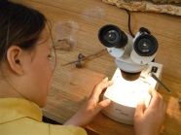

**Microscope.**

When we were inside some people got to look at

bugs and leaves and other things under a microscope.

Tarn looking at a microscope

**Carbon journey**

Also when we were inside,

we got to go through a journey of some carbon dioxide,

where we got cards and we went to all sorts of different places.

We had gone to Forestry Education Centre and had the most wonderful time.